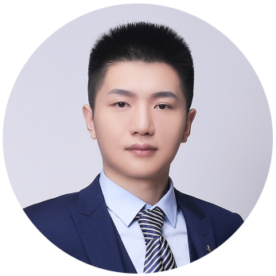

**Sep.2016 - Jun.2020 University of China International Economy and Trade**

* Main courses: International Economics, World Economic Introduction, International Trade Theory and Practice, International Finance, International Settlement, Monetary Banking, Finance, Accounting, Statistics, Business Communication and Correspondence (UK), International Investment, International Trade Simulation, etc.
* Honors and awards: 2 national scholarships, 3 second-class scholarships, ranking 1/50

**Sep.2018 - Oct.2018 Import and export co., LTD. Foreign trade intern**

* Supplier development: conduct mail inquiry for products, be responsible for finding customs declaration company, learn import and export goods declaration procedures and fees.
* Order follow-up: follow up the execution and completion of sales order contracts, complete the receivables and invoice issues, and follow up the follow-up work.
* Material arrangement: responsible for the material arrangement of sales contract, order contract.

**Sep.2018 - Oct.2019 Meten English Campus Ambassador**

* Promotion in school: Mainly responsible for the promotion of American Union English in school, through leaflet distribution, community communication and other means of publicity, to improve the popularity of American Union English in school.
* Question Answer: In view of the long distance between classes and the quality of courses, the teachers' Team Introduction and their own learning experience are used to eliminate the concerns.
* Main Achievements: More than 10 people attended the English Open Course, and about 8 people consulted after class.
* Professional Certificate: International Trade Documents Employees Qualification Certificate, International Trade Documents Certificate
* Language competence: CET-6, fluent oral English

**Aaron**

**Apply for Graduate University：New York University**

Shanghai 1998.09 135-0000-0000 123456789@163.com

**Skills**

**Education**

**Social practices**

* A fresh graduate from a Chinese university. I want to apply for a master's degree in economics at New York university.
* During the undergraduate period, I completed all the courses in the professional field, mastered good theoretical knowledge, and won many honorary awards.
* The following is my education, campus experience and social practice introduction.

**Introduction:**